GRAPHIC DESIGN CONTEST
Must submit artwork to the front office by:
March 27th, 2015
ARE YOU A GRAPHIC ARTIST?
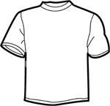

Submit you graphic design to be the inspiration for
FSMS fall 2015 spiritwear on an 8 x 11 piece of paper with your name and contact info on the back.
We are looking for simple designs that can be printed in one or two colors.
For more information or to submit your art
Please contact:
elliedamiano@yahoo.com
sadafpatel1@gmail.com

